|  |
| --- |
|  |
| Star Schema Basics |

|  |  |  |  |  |  |
| --- | --- | --- | --- | --- | --- |
| REVISION HISTORY | | | | | |
| Ver. | Description of Change | Author | Date | Approved | |
| Name | Effective Date |
| 1.0 | Initial status | Arina Marchenko | 08-11-2017 |  |  |

Contents

1. Data Modelling Task 2

2. Analytical task 5

# Data Modelling Task

Business model:

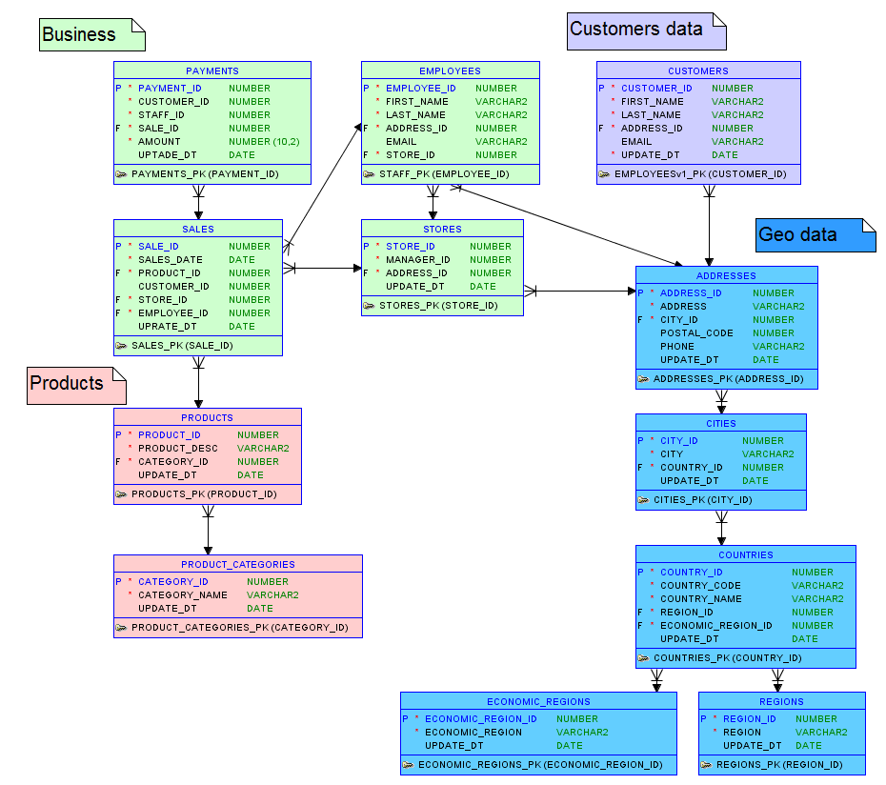

Star schema:

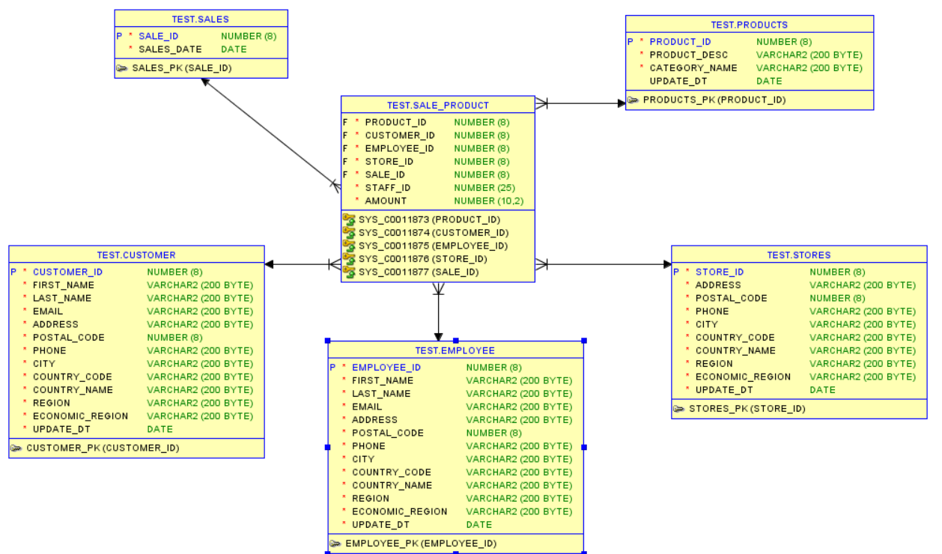

Snowflake schema:

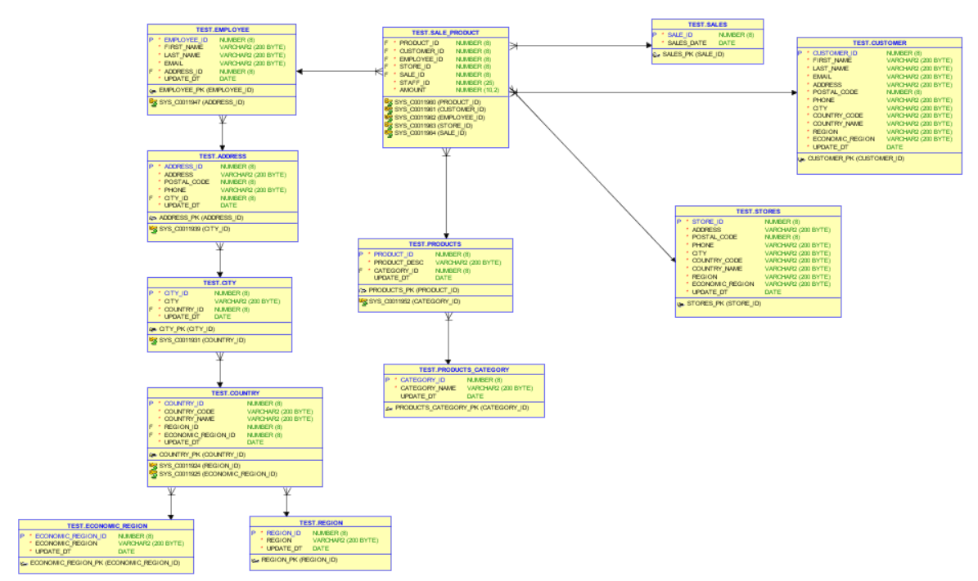

* The business procass is a sales product. Dimensions show detail information about sales like customer name, product description, category name, address of store and so on.
* The grain of this model is a product, ordered by customer.
* In Store there is information about the location and contacts of each store. In Customers there is information about each customer location and contact info. In Employee there is information about each employee (including name and surname, postal code, address and email) In Sales_Date there is information about sales date. In Products there is information about product category and product names.
* Fact is consists of composition of different ID from dimentions. Fact table represents the fact of bargin.

# Analytical task

1. Nowadays there are many different ways of buying cars. Thousands of cars are sold and bought daily. Moreover, sometimes it is complicated to keep track of all changes in car prices and the popularity of models especially because of the huge amount of different characteristic such as vehicle type, fuel type, and gearbox.
2. The problems that business is facing because of poor data management are that it is so complicated to find all the information about the cars such as price, year of registration, model and kilometer in one place. Usually this information divided into small pieces in different places. In addition, it is hardly to find the information about different types of model in one place.
3. With the help of data warehouse, it would be easier to find the information about cars, building different types of reports. In addition, it could be possible to see the difference in sales per years or per model, or per price. Completed information about car sold will be in one place.

This DWH would be suitable either for people, who wanted to buy a car, or for that people, who are interested in evaluation of the situation in the car market.